API Versioning

🌐 What is an API Versioning
# Source: AI Source: Provided by: [Data Path: Persons Table -> ID Column: 1, Name_En Column: Motasem Essam] -> From: [ChatGPT] on [1/19/2026]
API Versioning is the practice of managing changes and updates to an API without breaking existing clients. It allows developers to introduce new features, fix bugs, or improve endpoints while maintaining backward compatibility.
👉 Think of API versioning as version numbers for your API, just like software releases.

🔑 Why API Versioning is Important
# Source: AI Source: Provided by: [Data Path: Persons Table -> ID Column: 1, Name_En Column: Motasem Essam] -> From: [ChatGPT] on [1/19/2026]
- Backward Compatibility – Existing clients continue to work even after API updates
- Controlled Upgrades – New features or changes can be rolled out gradually
- Clear Communication – Clients know which API version they are using
- Error Prevention – Avoids breaking applications due to unexpected changes

🧱 Common Versioning Strategies

1️⃣ URL Path Versioning
# Source: AI Source: Provided by: [Data Path: Persons Table -> ID Column: 1, Name_En Column: Motasem Essam] -> From: [ChatGPT] on [1/19/2026]
- Include version in the URL
- Example:
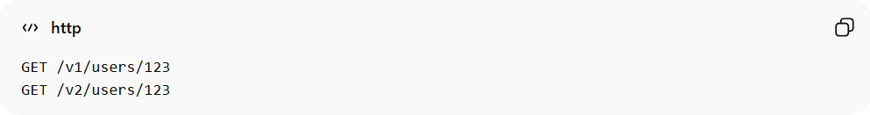
GET /v1/users/123
GET /v2/users/123

2️⃣ Query Parameter Versioning
# Source: AI Source: Provided by: [Data Path: Persons Table -> ID Column: 1, Name_En Column: Motasem Essam] -> From: [ChatGPT] on [1/19/2026]
- Specify version as a query parameter
- Example:
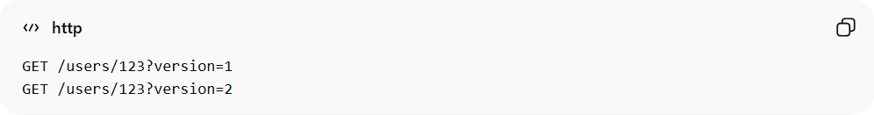
GET /users/123?version=1
GET /users/123?version=2

3️⃣ Header Versioning
# Source: AI Source: Provided by: [Data Path: Persons Table -> ID Column: 1, Name_En Column: Motasem Essam] -> From: [ChatGPT] on [1/19/2026]
- Specify version in a custom header
- Example:
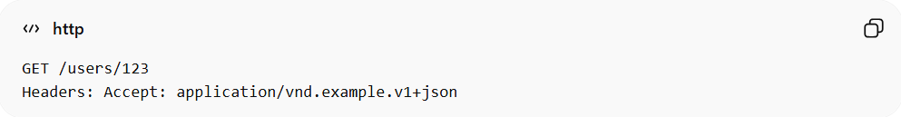
GET /users/123
Headers: Accept: application/vnd.example.v1+json

4️⃣ Content Negotiation / Media Type Versioning
# Source: AI Source: Provided by: [Data Path: Persons Table -> ID Column: 1, Name_En Column: Motasem Essam] -> From: [ChatGPT] on [1/19/2026]
- Version included in Accept or Content-Type header
- Example:
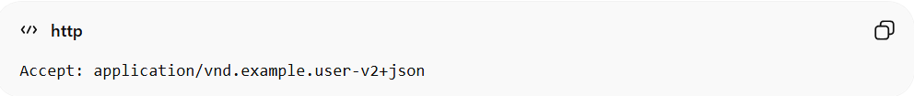
Accept: application/vnd.example.user-v2+json

✅ Best Practices
# Source: AI Source: Provided by: [Data Path: Persons Table -> ID Column: 1, Name_En Column: Motasem Essam] -> From: [ChatGPT] on [1/19/2026]
- Start with v1 for the initial release
- Keep major versions for breaking changes
- Use minor or patch versions for backward-compatible updates
- Clearly document versions for clients

❌ Common Mistakes
# Source: AI Source: Provided by: [Data Path: Persons Table -> ID Column: 1, Name_En Column: Motasem Essam] -> From: [ChatGPT] on [1/19/2026]
- Not versioning the API at all ❌ → breaks existing clients on changes
- Changing API behavior without updating version ❌
- Using inconsistent versioning methods across endpoints ❌

💡 Summary
# Source: AI Source: Provided by: [Data Path: Persons Table -> ID Column: 1, Name_En Column: Motasem Essam] -> From: [ChatGPT] on [1/19/2026]
API Versioning ensures that updates, improvements, or breaking changes do not disrupt existing clients, enabling stable and maintainable APIs.

